Guidelines for authors and sample manuscript

Author KIKAI*, Author YAMA* and Author UMI**

*Japan Society of Mechanical Engineering

4-1 Shin-ogawamachi, Shinjuku-ku, Tokyo 162-0814 Japan

E-mail: icmpconf2022@jsme.or.jp

**Department of Mechanical Engineering, Kikai University

4-1 Shin-ogawamachi, Shinjuku-ku, Tokyo 162-0814 Japan

|  |
| --- |
| Abstract  The length of the abstract should be 100-200 words. In the beginning of the abstract, the subject of the paper should be stated clearly, together with its scope and objectives. Then, the methods, equipment, results and conclusions in the paper should be stated concisely in a sufficiently logical manner. The discussion on the results may also be stated to emphasize their importance appropriately. -----------------------------------------------  ------------------------------------------------------------------------------------------------------------------------------------------------------------------------------------------------------------------------------------------  Keywords : Term, Term2, Term3, Term4,…(Show five to ten keywords) |

1. Introduction

The format of the proceedings of the JSME International Conference on Material Processing (ICM&P) 2022 follows that of Mechanical Engineering Journal of JSME. In preparing the manuscript with Microsoft (MS) Word, please read and observe this sample manuscript carefully.

The minimum length of the manuscript is 3 pages. The recommended structure of a manuscript is as follows: Introduction (purpose of the research, significance of the research supported by a literature survey, outline of contents, and so on), Nomenclature (symbols and subscripts, and so on), Main body of the text (theoretical analysis, method and results of experiment, interpretation of results and discussion, and so on), Conclusion (conclusions obtained through the research), Acknowledgment, Appendixes, References.

Apart from the above example, a different structure of manuscript may be accepted if it is the most suitable and effective style for the contents of the manuscript.

2. Title, authors' name and affiliations

The title should be concise but sufficiently descriptive to identify the contents of the paper. A lively and informative one may be preferred. A subtitle may be used as needed, although expressions such as "the first report" and "the second report" are not acceptable. Nonstandard abbreviations and acronyms should be avoided in the title. Only the first word of title should be capitalized.

The names of authors should be placed immediately below the title. The given names and family names should be spelled out with each character of family names capitalized. In the address (all authors’ addresses should be listed except when multiple authors the same address), give the prefecture, ward, city and postal code. Give "the country name" at the end of the address, and provide the e-mail address of the contact person.

(Example)

Department of Mechanical Engineering, Shinjuku University,

4-1 Shin-ogawamachi, Shinjuku-ku, Tokyo 160-0016, Japan

E-mail: icmpconf2022@jsme.or.jp@jsme.or.jp

Do not provide e-mail addresses of authors other than the contact person.

3. Headings

The main body of the text should be suitably divided into sections (and if necessarily subsections), each with a heading. For instance,

4. Compensation of flow disturbance using estimated signal

4.1 Estimation of flow disturbance

4.1.1 Axisymmetric disturbance

5. Abstract

Title and abstract are the keys to your work. The length of the abstract should be 100-200 words. The abstract should appear immediately following the title, authors' names and affiliations. In the abstract, the authors should clearly state the contents of the manuscript so that readers can understand the contents of the paper without reading the main body.

Our journals place importance on the sufficiently informative abstract. Authors should carefully prepare the abstract, referring to the following instruction: In the beginning of the abstract, the subject of the paper should be stated clearly, together with its scope and objectives. Then, the methods, equipment, results and conclusions in the paper should be stated concisely in a sufficiently logical manner. The discussion on the results may also be stated to emphasize their importance appropriately. A summary leading to conclusions is not required. Figures, tables and references in the text should not be cited. If the citation of an equation is unavoidable, the full equation should be given rather than citing only the equation number. Do not insert line feeds in the abstract, i.e., the abstract should be written as only one paragraph.

6. Keywords

Five to ten keywords should be given below the abstract. The keywords should be chosen so that they would best describe the contents of the paper. They are also useful in the classification and search of papers. The use of hyphens, prepositions and articles should be avoided. Capitalize the initial letter of each word.

7. Figures, tables, photographs and online supplements

Figures, photographs and tables can be used to describe clearly and accurately the contents of the paper. In general, figures are useful for presenting general tendencies, and tables are suitable for presenting specific numeric values and data. The use of figures, tables and others should be limited to important and representative ones that make the authors' statement persuasive. Since our journals are on-line journals, figures, photographs and tables can be presented in color.

Figures and tables should be presented with sufficiently informative captions. Too short captions are not accepted except when they are enough. Every caption should be complete and intelligible by itself without references to the text. See an example shown below. When figures from other papers are reprinted, the permission of the original authors is required.

|  |  |
| --- | --- |
| Recommended | Not recommended |
| 0.357 | .357 |
| 3.141 6 | 3.141,6 |
| 3.141 6×2.5 | 3.141 6・2.5 |
| 3.141 6×103 | 3.141 6E+3 |
| 1000 or 1 000 | 1,000 |

Table 1 Examples of writing numbers.

|  |  |
| --- | --- |
| Recommended | Not recommended |
|  | √ |
|  |  |

Table 2 Examples of writing a square root and a fraction.

Table 3 Physical properties of air at atmospheric pressure.

|  |  |  |  |  |  |  |  |
| --- | --- | --- | --- | --- | --- | --- | --- |
| [oC] | [kg/m3] | [J/(kg·K)] | [Pa·s] | [m2/s] | [W/(m·K)] | [m2/s] |  |
|  |  | ×103 | ×10-5 | ×10-5 | ×10-2 | ×10-5 |  |
| 0 | x.xxxx | x.xxx | x.xxx | x.xxx | x.xxx | x.xxx | x.xxx |
| 10 | x.xxxx | x.xxx | x.xxx | x.xxx | x.xxx | x.xxx | x.xxx |
| 20 | x.xxxx | x.xxx | x.xxx | x.xxx | x.xxx | x.xxx | x.xxx |
| 27 | 1.1763 | 1.007 | 1.862 | 1.583 | 2.614 | 2.207 | 0.717 |
| 30 | x.xxxx | x.xxx | x.xxx | x.xxx | x.xxx | x.xxx | x.xxx |
| 40 | x.xxxx | x.xxx | x.xxx | x.xxx | x.xxx | x.xxx | x.xxx |
| 50 | x.xxxx | x.xxx | x.xxx | x.xxx | x.xxx | x.xxx | x.xxx |
| 60 | x.xxxx | x.xxx | x.xxx | x.xxx | x.xxx | x.xxx | x.xxx |
| 70 | x.xxxx | x.xxx | x.xxx | x.xxx | x.xxx | x.xxx | x.xxx |
| 80 | x.xxxx | x.xxx | x.xxx | x.xxx | x.xxx | x.xxx | x.xxx |
| 90 | x.xxxx | x.xxx | x.xxx | x.xxx | x.xxx | x.xxx | x.xxx |
| 100 | x.xxxx | x.xxx | x.xxx | x.xxx | x.xxx | x.xxx | x.xxx |

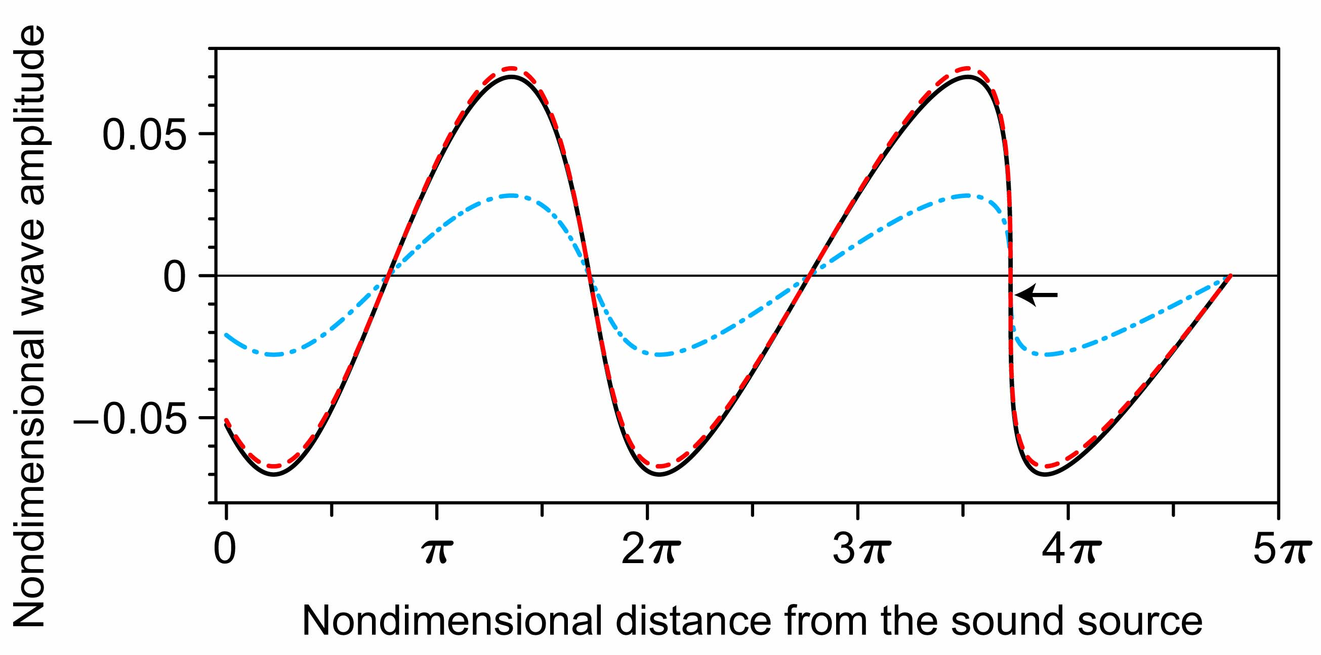

Fig. 1

The nonlinear propagation of plane acoustic wave radiated by the sound source. Using the exact solution of the system of Euler equations, the nondimensional profiles of fluid velocity, acoustic pressure and temperature variation at the time of shock formation are plotted with the solid (black), dashed (red) and dash-dotted (blue) curves, respectively. As the wave propagates, the nonlinear effect accumulates to distort the profile, and ultimately leads to the formation of shock wave. The shock formation point is denoted by a small arrow in the figure.

8. Citation of equations, references, tables, figures and others in the text

At the beginning of a sentence, "Equation" and "Figure" should not be abbreviated. Within a sentence, an equation is cited with the number and "Eq." for example, "Eq. (1)," and at the beginning of a sentence, it should be written out as "Equation (1)." Within a sentence, a figure should be cited with "Fig.," for example, "Fig. 1," and at the beginning of a sentence, it should be written out as "Figure 1."

 (1)

 (2)

 (3)

 (4)

Italic type must be used for physical and mathematical symbols. Upright Roman type may be used for differentiation operator d as shown in Eq. (1).

9. References

Citations in the text are indicated by author’s last name and year with the list of references arranged in alphabetic order: for example, (Ahrendt and Taplin, 1951) or the book by Ahrendt and Taplin (1951). For a reference from three or more authors, the citation in the text is indicated by the first author's name followed by "et al." and the year: for example, (Takeuchi et al., 2006). More than one reference from the same author(s) in the same year are identified by the letters "a", "b", "c", placed after the year: for example, (Karin and Hanamura, 2010a, 2010b). Unpublished works (including papers not yet submitted or not yet published) should be avoided. The complete name of the journal referred to should be given. Cite references published as recently as possible. It is recommended for contributors to cite articles published in journals of the JSME, if possible. If a reference is not written in English, authors are required to translate the title into English and indicate the original language as "(in Japanese)," for example. See an example below.

References

Ahrendt, W. R. and Taplin, J. F., Automatic Feedback Control (1951), p.12, McGraw-Hill.

International Federation of Library Associations and Institutions, Digital libraries: Resources and project, IFLANET (online), available from <http://www.ifla.org/II/htm>, (accessed on 30 November, 1999).

Kameyama, H., Production method of thermal conductive catalyst, Japanese patent disclosure H00-100100 (1990).

Karin, P. and Hanamura, K., Microscopic visualization of PM trapping and regeneration in a diesel particulate catalyst-membrane filter (DPMF), Transactions of Society of Automotive Engineers of Japan, Vol.41, No.1 (2010a), pp.103–108.

Karin, P. and Hanamura, K., Microscopic visualization of particulate matter trapping and oxidation behaviors in a diesel particulate catalyst-membrane filter, Transactions of Society of Automotive Engineers of Japan, Vol.41, No.4 (2010b), pp.853–858.

Keer, L. M., Lin, W. and Achenbach, J. D., Resonance effects for a crack near a free surface, Transactions of the ASME, Journal of Applied Mechanics, Vol.51, No.1 (1984), pp.65–70.

Nagashima, A., New year's greeting, Journal of the Japan Society of Mechanical Engineers, Vol.108, No.1034 (2005), pp.1–2 (in Japanese).

Tagawa, A. and Yamashita, T., Development of real time sensor for under sodium viewer, Proceedings of the 19th International Conference on Nuclear Engineering (ICONE-19) (2011), Paper No. ICONE19–43187.

Takeuchi, S., Yamazaki, T. and Kajishima, T., Study of solid-fluid interaction in body-fixed non-inertial frame of reference, Journal of Fluid Science and Technology, Vol.1, No.1 (2006), pp.1–11.

Takeuchi, Y., Ultraprecision micromilling technology, Transactions of the Japan Society of Mechanical Engineers, Series C, Vol.71, No.701 (2005), pp.1–4 (in Japanese).

The Japan Society of Mechanical Engineers ed., JSME Data Handbook: Heat Transfer (1979), p.123, The Japan Society of Mechanical Engineers (in Japanese).

Tsutahara, M. Tamura, A. and Kataoka, T., A study of SIS of surfactant by the finite difference lattice Boltzmann method, Proceedings of the 16th Computational Mechanics Conference (2003), pp.121–122 (in Japanese).

Watanabe, T., Sakai, Y., Nagata, K., Terashima, O., Ito, Y. and Hayase, T., DNS of turbulent Schmidt number and eddy diffusivity for reactive concentrations, Transactions of the JSME (in Japanese), Vol. 80, No. 809 (2014), DOI:10.1299/transjsme.2014fe0008.